Getsafe Finance Data Case Study

Objective :
The objective of this project is to design a simple and reliable analytics layer for finance reporting.
This project focuses on:
- Building a semantic layer for the finance team to report premium metrics consistently.
- Identifying differences between finance and accounting data, and creating a repeatable reconciliation process.
- Designing reporting marts that can be directly used in BI tools for KPI dashboards.
- Creating a maintainable dbt structure that can support future reporting, performance and data quality needs.

Assumptions:
- Gross Premium Calculation: Defined as the total premium value where the status is marked as "Processed.
- Net Premium Calculation: Calculated by subtracting "Refund" status values from "Processed" status values
- Status Standardization: Inconsistent entries in the status column were standardized to "Processed" to ensure calculation integrity, e,g ‘process’
- Data Latency: Missing data for September in the Accounting dataset is assumed to be a result of the late month-end closing process.
- Premium Definition: Accumulated premium in Task 2 is calculated based on contracted premiums rather than actual cash collected.

Analytics:
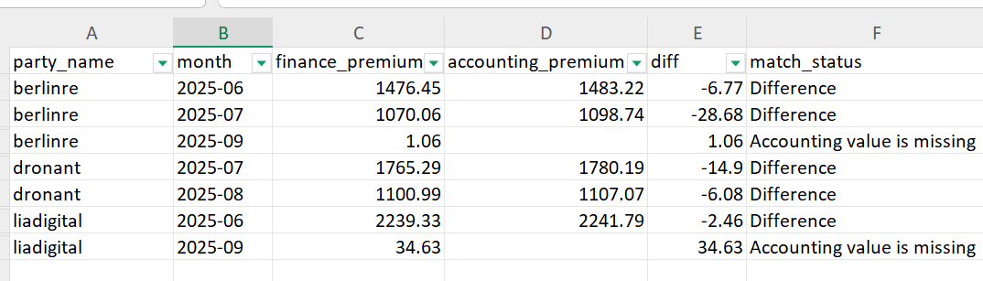

Root cause

- Systematic Variance: The 5 identified discrepancies range from €2.46 to €14.90 . Accounting values are consistently higher than finance values. This suggests a potential lag in database updates compared to the real-time tracking utilized by stakeholders.
- Incomplete Data: The 2 missing entries pertain specifically to September records from the Accounting team. As this data has not yet been shared, these cannot be classified as mismatches at this time
- Temporal Factors: While time zone differences impact day-level reporting, they do not significantly alter high-level monthly aggregates

Recommendations
1.Standardize Metric Definitions: Align both teams on a unified definition of "Premium." It is critical to determine if Accounting utilizes Gross or Net values to resolve the current variance.
2.Establish a Single Source of Truth: Document the rationale for existing metric differences and move toward a standardized reporting framework.
3.Automate Data Validation: Implement automated checks to identify and flag discrepancies between finance and accounting systems in real-time.
4.Introduce a Reporting Buffer: Implement a 2-3 day lag for monthly calculations to allow for data synchronization and ensure accurate final figures.
5.Fix the source pipeline:Raise a ticket with the payment system team to correct the ‘process’ status typo at source so it does not happen again.

Future changes

Dimensional Modeling: Establish a dedicated dim_status table to accommodate future status logic and enhance the overall schema scalability.
Performance & Cost: Transition fact_customers_daily to an incremental model improve query to performance and minimize data warehouse compute costs price.
Quality Assurance: Deploy custom, business-level dbt tests to eliminate data quality issues and standardize testing processes
Data Governance: Integrate a robust data governance framework(adding the row level security, defining roles etc) tailored to business needs to manage critical data assets.
AI-Optimized Schema Architecture: Re-design the schema.yml to define semantic models for AI usage with detailed descriptions, entity aliases, and strict join constraints.

